JAVASCRIPT

Why we study javascript?

It is the only programming language that will understand by browser.

What is programming language?

It is a language in which we can implement our own logics and apply that to the computer is known as programming language.

What is a browser?

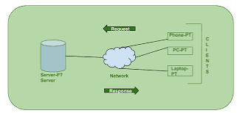

What are primitives?

Smallest possible division which cannot be further broken down i.e., is the building blocks.

How many primitive data types in JavaScript?

There are seven primitive data types

* Number (int &float)
* Boolean
* String (char/string)
* Undefined
* Null
* Symbol
* Big int

What is a variable?

Variable is names which hold some values.

Example: Let age=26;

Let Umar= ‘Akmal’;

Here we do not have need to define the types of data store in variable.

What is Nomenclature?

Way to declare variable means which name we should given to variable.

(a-z, A-z,0-9,)

( _, $)

Number se start Nahi kara skate Hai.

Predefined keywords not used as variable.

Can we start with _ ,$ yes it is possible

Way of defining variable:

Normal case:

Let Venugopaliyer= “gas”;

Camel case:

Let VenuGopalIyer= “gas”;

Snake case:

Let Venu_Gopal_Iyer= ‘saanp’;

Kabab case: We cannot use case

Let Venu-gopal-Iyer= “Bhopal”;

What is console?

Console is REPL(Read , evaluate, print ,loop)

JavaScript is interpreted(line by line), Weakly typed(where the data type of the variable is not fixed), dynamically typed(at runtime data type is defined), single threaded( at a point of time one work occur multiple task not possible) .

Note: We write script tag at html end.

Note: We do not write principle of separation of concern

Note:console.log is used to print

Primitive :

1. String:

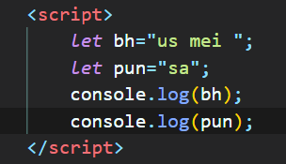

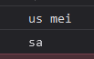

What is Declarative?

Var, let, const is declarative which helps to define variable.

Ways to define string:

1. Let var_char= “gal”;
2. Let varchda= ‘gal’;
3. Let varchaj= `ffl`;

Advantage of ` @`



With the help of backticks we do not need to use ‘+’ symbol to concat for use this variable we use ${var}

Number:

typeof() is a function which defines datatypes

order of arithmetic opeations:

PEMDAS(Parnathesis, Exponential, Multiply, Division, addition , subtraction)

Short circuit test:

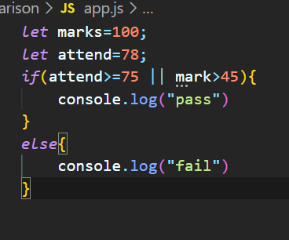

In this we do not define mark variable but first criteria is true so we do not do attend.

Function:

Syntax : function <function name>(){}

For Function calling functionname();

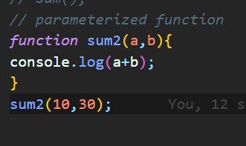

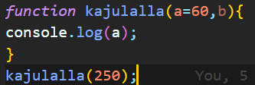

If parameter function is passed and default value is also given then passed value has more value then default value